- For each time the mouse wheel is scrolled, the page should move to the next section. It should not stop between 2 sections
- Delete any development notes in the website. It should not look like AI slop. It should always looks production ready, even though if it still has some work to do.

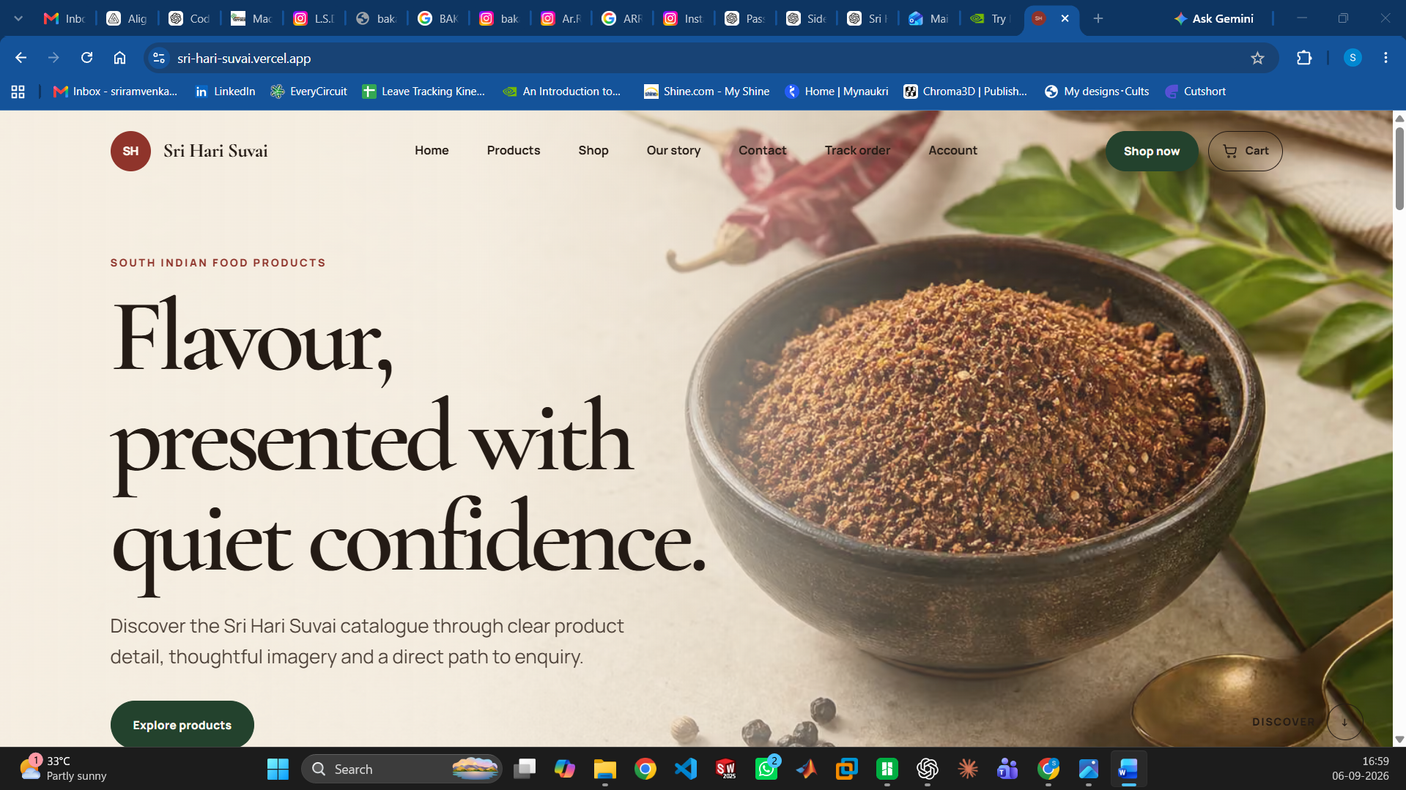
- Sri Hari Suvai Logo to be included instead of the round “SH”
- The Name “Sri Hari Suvai” inside the Navigation Bar/Header Bar to be increased in size
- The font size of the sentence “South Indian Food Products” to be increased
- Decrease the font size of “Flavour, presented with quiet confidence.”
- Displace everything a bit above, so that the page section stays within the window

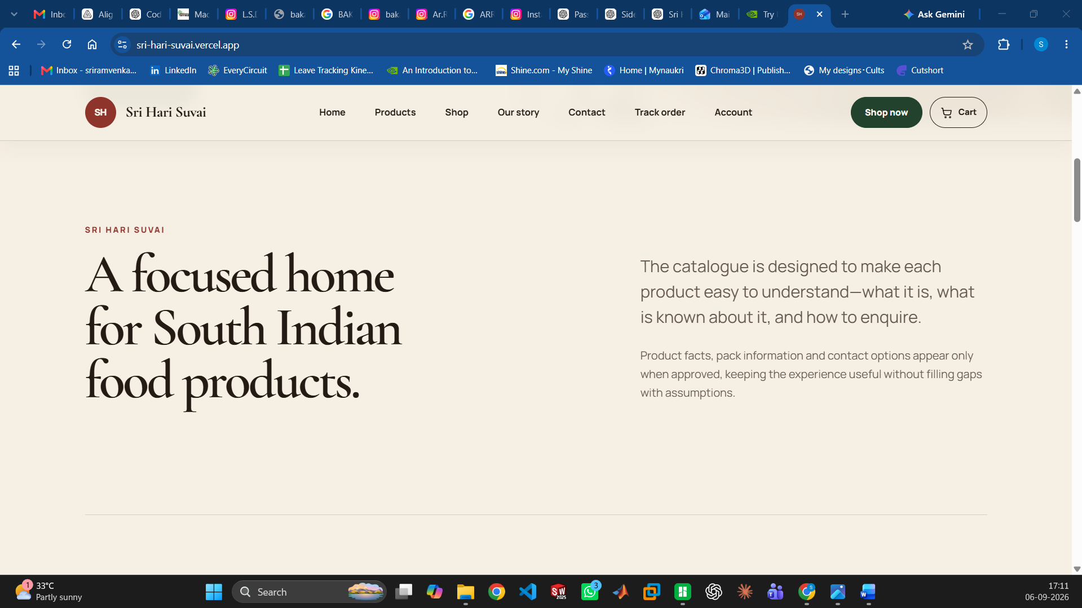
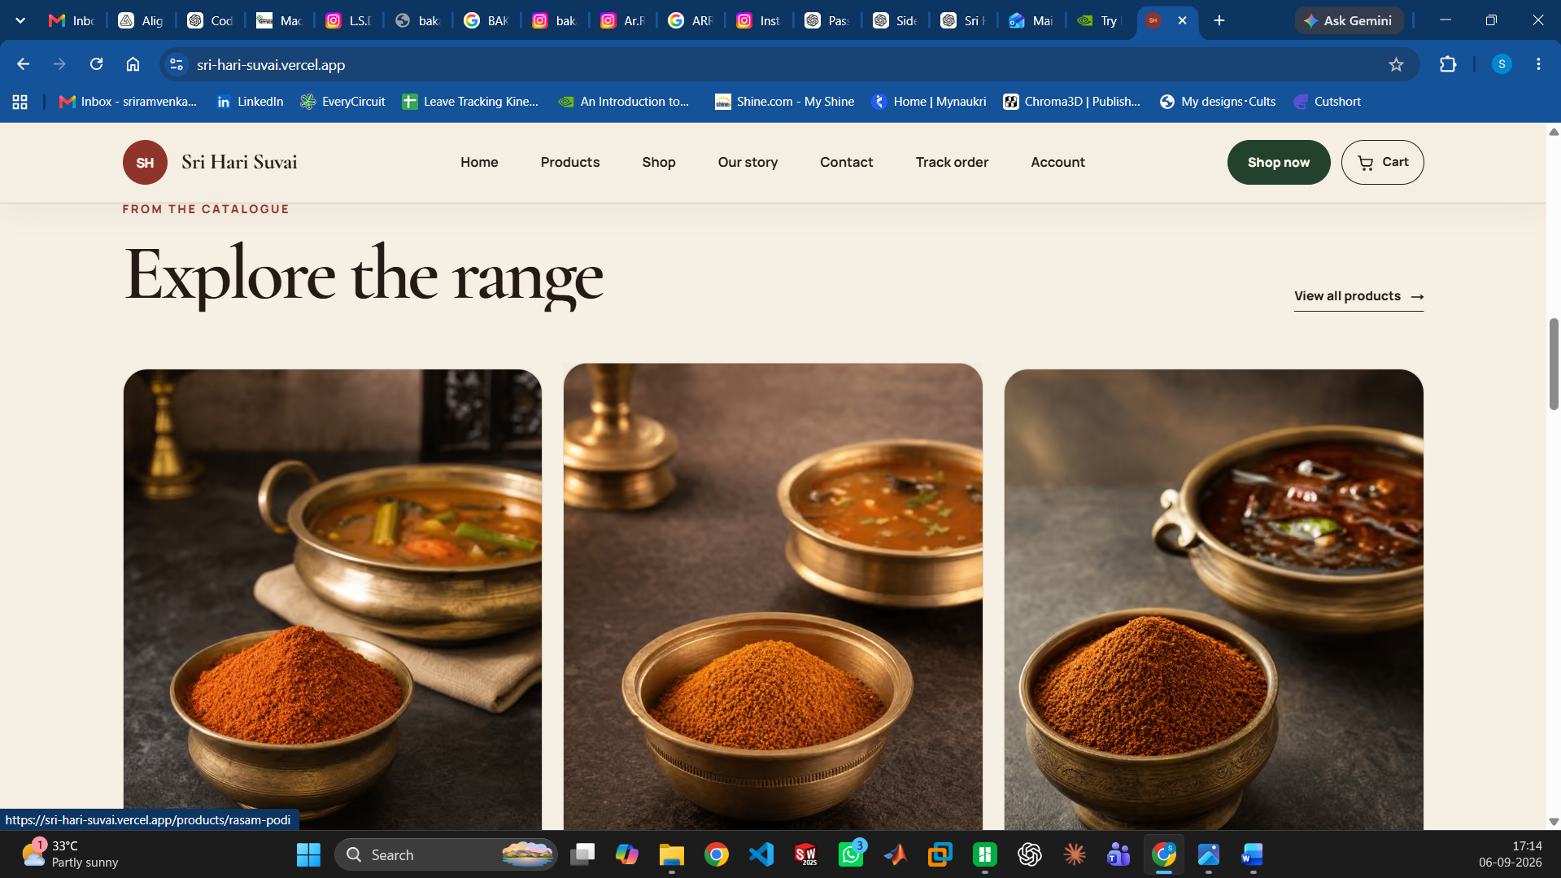
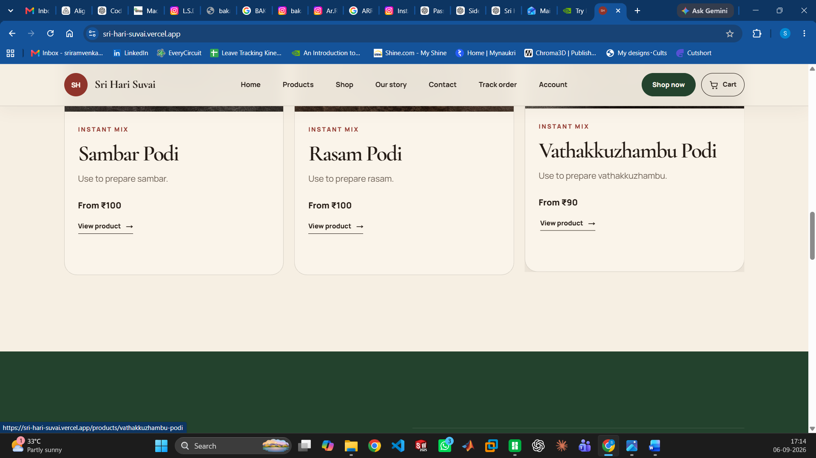
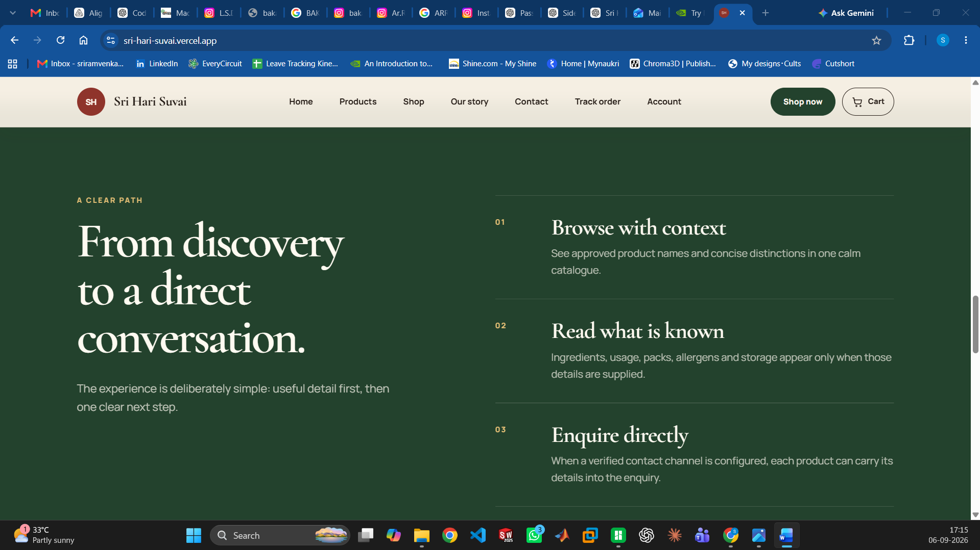
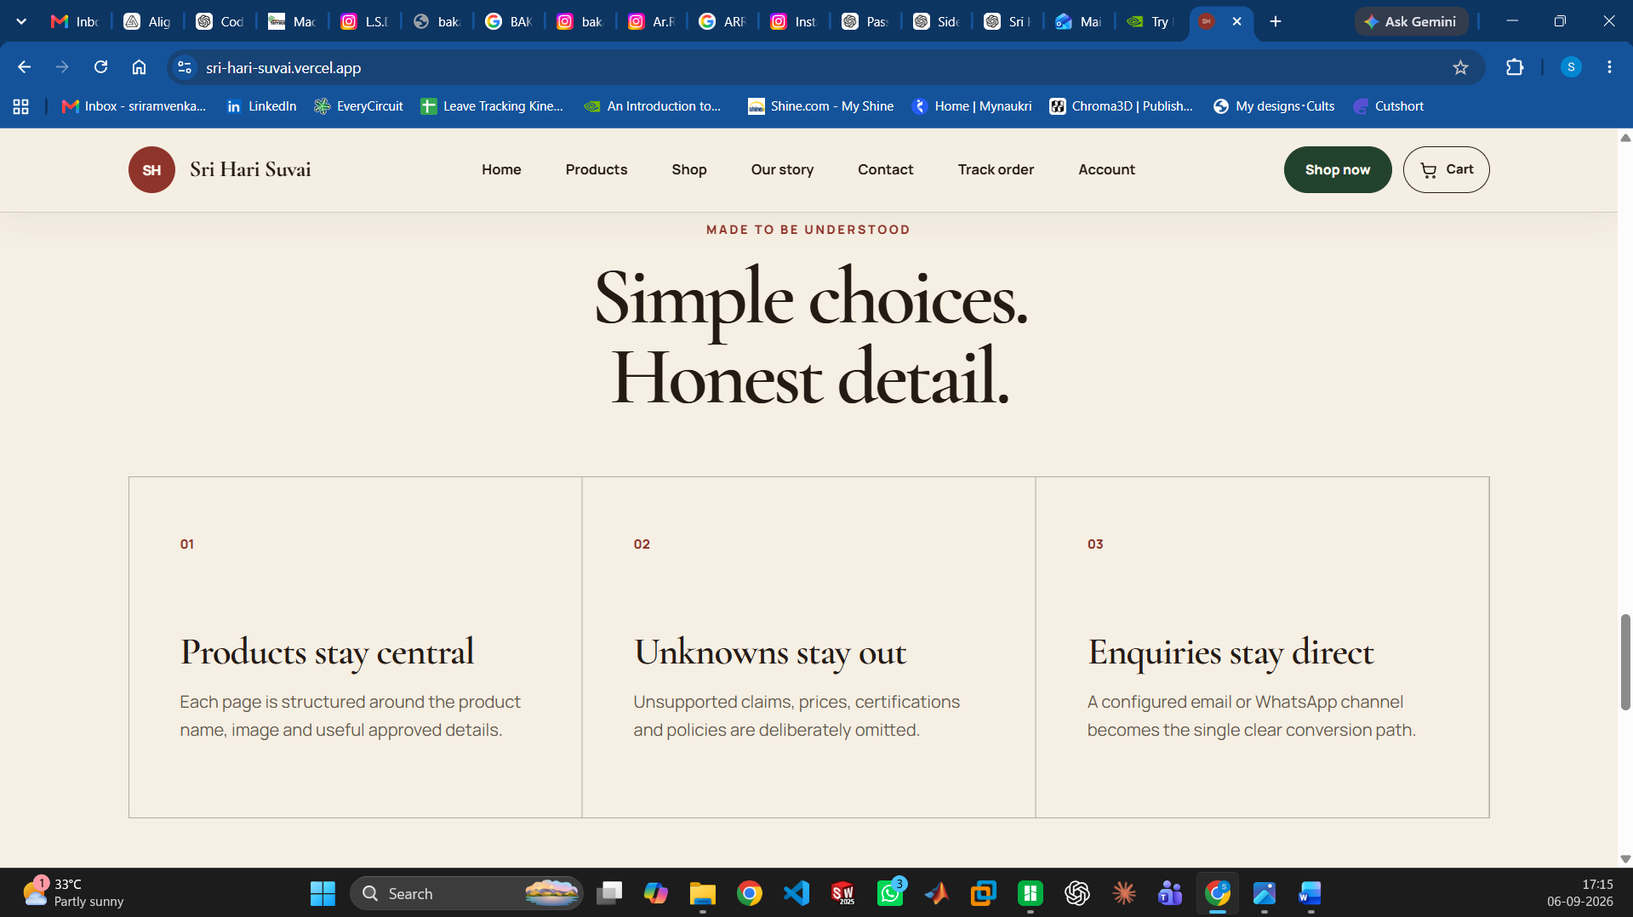
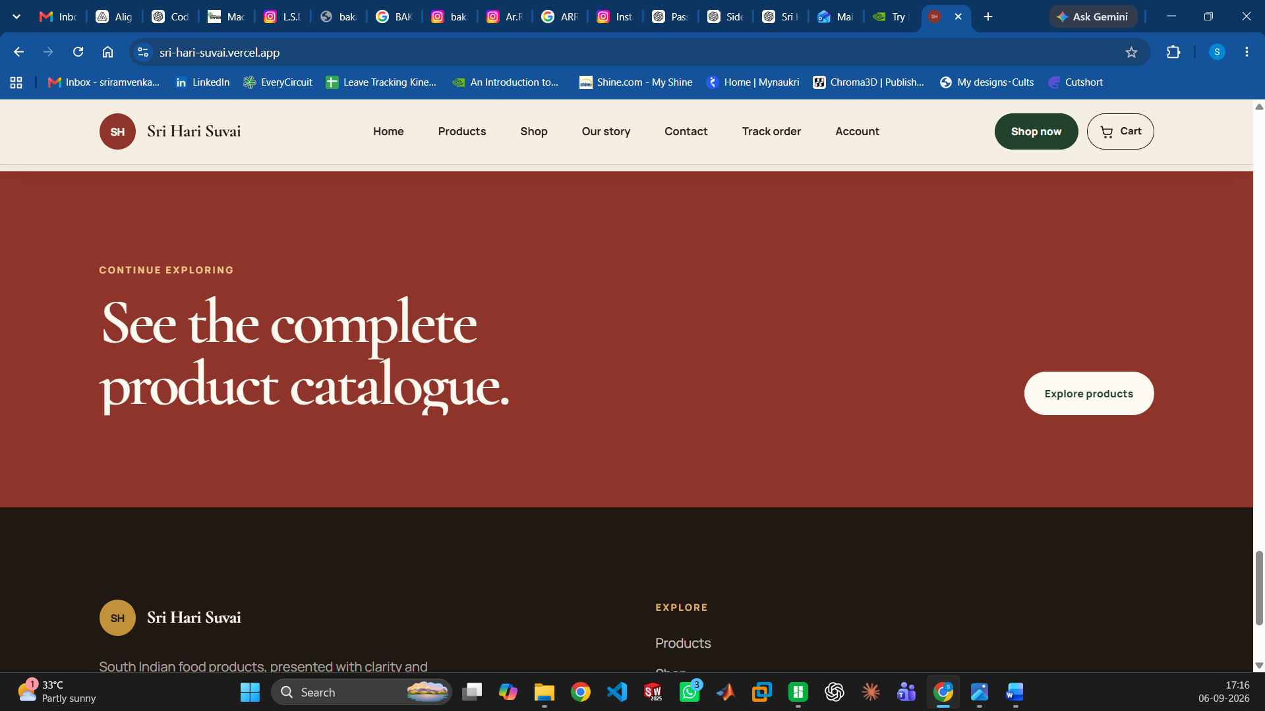
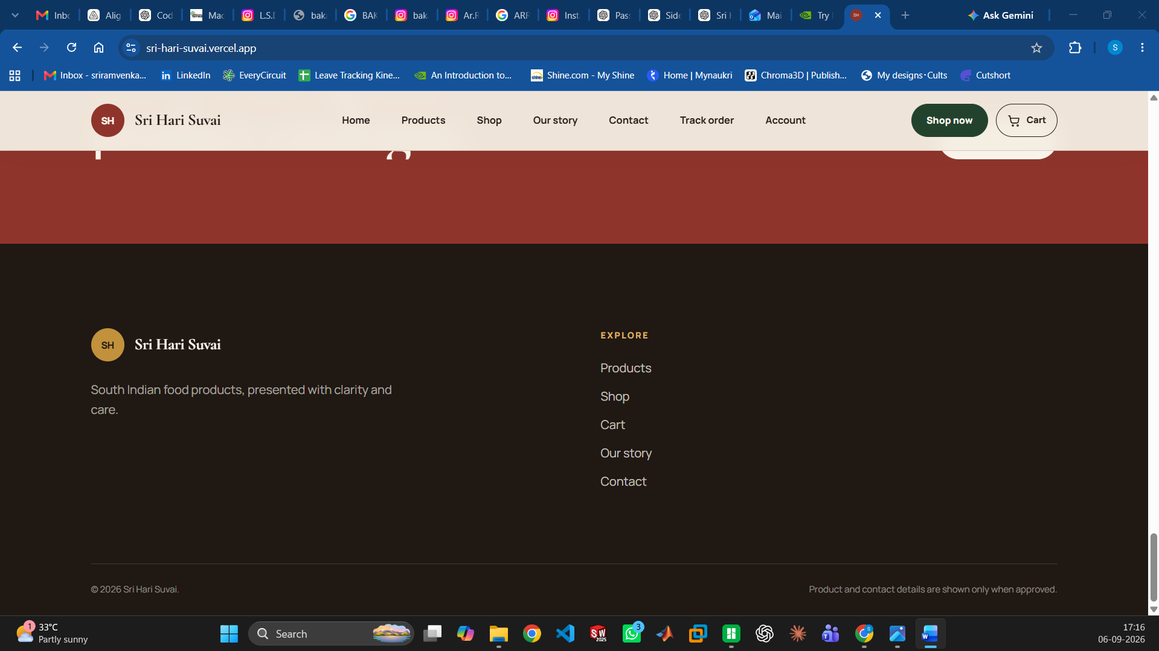
- These sections looks bland… Do you really think we need this ??? Think from a customer PoV and answer… Will you read all these if you were the customer ???
- I need the website to be like an E-Commerce, not some generic wordpress or blog with images

